Find a website with a problematic user interface / lacks usability and submit your answers in word document for the following 5 questions: (This lab is worth 2%)

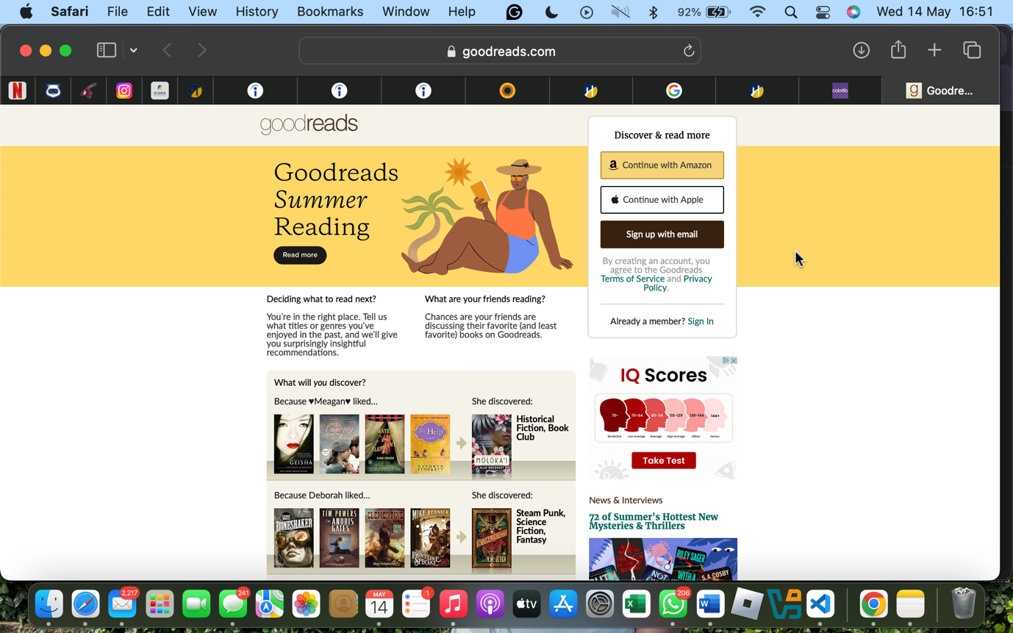

1. **URL of the site evaluating**
2. **Targeted audience**
3. **Things you like**

* **Comprehensive Book Database**: Goodreads boasts an extensive collection of books, making it a valuable resource for readers.
* **Active Community Engagement**: The platform offers various community features, such as groups and discussions, fostering interaction among users.
* **Reading Challenges**: Goodreads' reading challenges motivate users to set and achieve reading goals.

1. **Thing you don’t like**
2. **Suggestion for improvement**

* **Modernize the User Interface**: Updating the design to align with current web standards could enhance user satisfaction.
* **Enhance Search and Filtering Capabilities**: Improving these features would help users find books more efficiently. [Sarah Price](https://www.sarehprice.com/blog/goodreads-a-casestudy-of-outdated-ux?utm_source=chatgpt.com)
* **Improve Mobile Experience**: Ensuring the mobile version is responsive and feature-complete would increase accessibility.

It’s hard to believe that Goodreads’s desktop design and user experience are so poor. Hey, we’re speaking of a huge business.

Even though it’s far from the worst on this list, it features a way too basic design with terrible navigation.

Luckily, the mobile layout is much better, but it’s still better to download the app to get the most out of the platform.